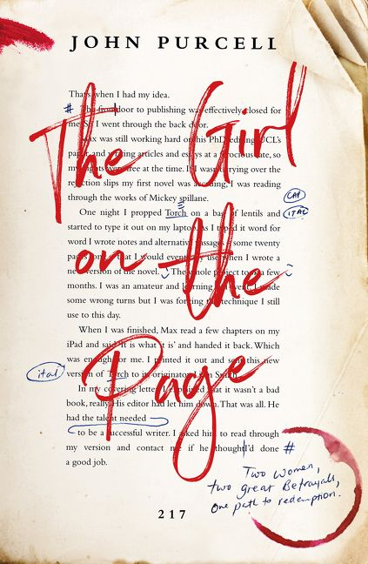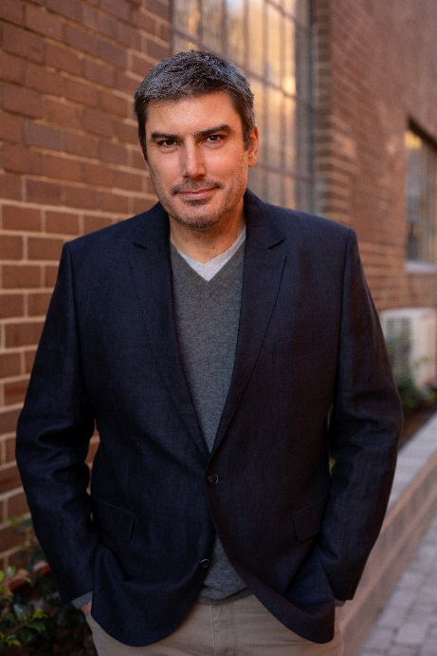

A Q&A with John Purcell, author of The Girl on the Page

Tell us about your experience writing The Girl on the Page. Where did the original idea come from? Why did you write it?
After a couple of years of very little writing I was suddenly inspired. I wrote The Girl on the Page quickly. I felt I knew the characters from the outset – writers and publishing types. They lived and breathed in my mind. All I had to do was throw them together and watch them interact. London was the perfect backdrop for my tale - a literary novel about the literary life. I love London. I have lived there and I have visited often. I love reading about London. I love walking its streets. I love the layers of stories, the layers of history.
I suppose the original idea for The Girl on the Page came to me while listening to Amy Winehouse’s Back to Black. I love how heartache doesn’t discriminate. Everything else in your life can be perfect, but if your heart is truly broken, there is only one trajectory open to you - downwards. It’s even worse if you’re the cause of your own heart break. If you’re the one who fucked it all up.
So, I had the character of Amy Winston, a writer and editor at the top of her game who, having betrayed the love of her life seems hell-bent on self-destruction. All I had to do was introduce her to Helen and Malcolm, two great writers nearing the end of their lives (and tethers) who have been shuffling around in my mind for the longest time.
I recently realised that I have been researching The Girl on the Page all my adult life, I just didn’t know it. I spent years reading like an old man while seated in my second-hand bookshop - dusty tomes of history, philosophy and literature. I was a walking talking anachronism. I was Malcolm. I was Helen. And then, when that life ended, I was thrust kicking and screaming into the modern world, landing a job with an online bookshop where I had to interview living writers about recently published books. And suddenly I was Amy.
I wrote The Girl on the Page to remind myself that selling out has its consequences.

Your book seems to make a point about the value of literature. Is there still room for artistic integrity in modern publishing?
Absolutely, but it isn’t financially viable. And this is a problem because it is usually the artists who do not bend who drag culture forward. If it wasn’t for government grants, literary prizes and the determination of artists to produce work in the hours outside their regular jobs, there wouldn’t be the thing we call literature. Literature isn’t a popular commodity. Most literary novels, even by esteemed authors, sell a few thousand copies and drop quickly out of sight. We, as a community, need to recognize the value such work for the work to become economically viable. It’s up to us all.

Your novel is set in the book industry, amongst writers and publishers, some of whom you name – such as Jojo Moyes, Michael Robotham etc - can we assume that your fictional characters are drawn from life?
You can if you’d like. I do mix with authors, publishers and booksellers as part of my day job. I hear many off the record stories about the book world during events. Then there are the mergers and acquisitions of publishers, the sudden job changes of well-known publishing figures and the hushed-up scandals. And the gossip. Doesn’t the literary world like to gossip! And don’t authors like to spin stories! But if you’re wondering if Helen and Malcolm are A.S. Byatt and Julian Barnes, or if Liam Smith is Matthew Reilly, or if Amy is someone I work with. All I can say is, maybe. Maybe not.

The novel draws a sharp distinction between commercial fiction and literary fiction - the character Malcolm seems especially opinionated on the subject – and seems to conclude that literature is the more valuable to society, a conclusion that has been disputed over recent years by lovers of genre fiction, is the reader to suppose that you are you a literary snob?
I have been called a snob in the past. Tara Moss once wrote it on my face in eyeliner. And I suppose when you scratch the surface I have all of the attributes of a snob. I read literary classics when I read for pleasure. I tend to drift towards modern literature if I’m reading for work and I do prefer the company of those who have a love for literature. But I have too much respect for writers of all stripes to confine myself to literature. In my work I have interviewed hundreds of writers about their work and whether you’re writing a picture book for babies, or a history of the Romanovs, it is a difficult creative endeavour. And I just love creative people.

The relationship between Daniel and his parents, Helen and Malcolm, is a complex one. I suppose my question is, do you think artists like Helen and Malcolm should have children?
Michael Chabon wrote an article recently about this. As a young man he was told by a literary great that for each child you have as a writer you lose one book you might have written. He gave examples of childless writers and thought of those with children. Many of the later were unhappy and less productive. Chabon concluded that children were worth it. And I think Helen and Malcolm would come to the same conclusion. Children are trouble whether you’re a writer or not. The raising children can seriously disrupt a life, but that experience teaches a writer much about people they wouldn’t necessarily discover alone. So although you might not write as much, your work will mostly likely be richer for the experience.
The character of Amy is like a tornado ripping through the book causing trouble everywhere she goes. She drinks too much, rarely sleeps in her own bed and she makes some questionable decisions which cause others great pain. Is this what you think all millennials are like?
I hadn’t thought of Amy as a millennial but now that you mention it I suppose she is. Whatever traits she shares with the stereotype of the millennial are accidental, or unconscious. To be young, to my mind, is to create havoc, if you’re doing it right. Youth is the time to test limits, to cross boundaries, to break hearts and have your heart broken. Living well means examining life. Moral and ethical standards sometimes don’t fit the individual and need to be stretched and ripped. And it is much better to do this early. A millennial in this picture is just a young person. And young people do what young people do. If they’re playing for keeps.

The Girl on the Page by John Purcell is published by Fourth Estate & available September 24 wherever great books are sold.

